Congratulations! While visiting your classroom today, you were implementing a Keys to Literacy strategy presented at the KTL training you attended. Thank you for adopting this district initiative and making Keys to Literacy a routine in your classroom.

Gotcha
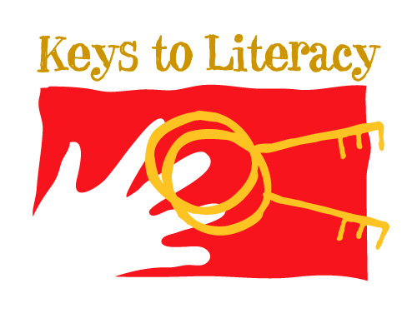

using a KTL
strategy in
class today!

“Gotcha” Card Directions

- Print the first page of this document using a color printer.
- Fold the paper in half, and then again, making sure the colored “Gotcha” side is on the front of the card.
- A KTL coach or building/district administrator can sign one of these cards and pass them out to teachers as a way to encourage them to keep implementing KTL strategies.
- Please feel free to modify the card in any way!

