**Key Comprehension Routine: The Role of the Building Coach**

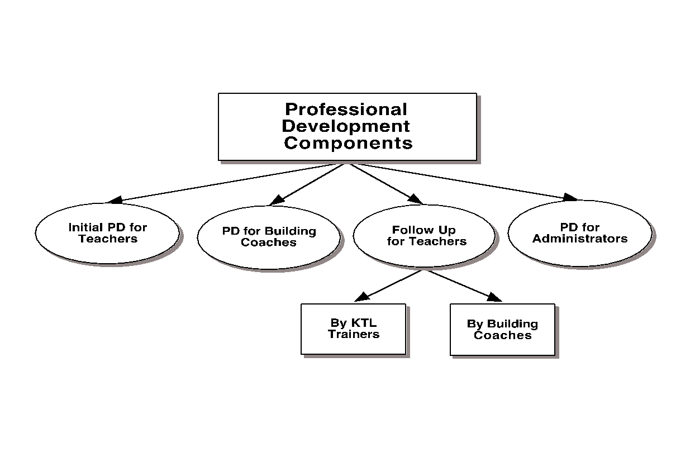

As we continue to implement the strategies from the *Keys to Content Writing* as part of our district and school improvement plans, a critical component to an effective PD model is the role of the building based coach. The **purpose of the coach** role is to create building level support as teachers implement the focused best practices from our literacy professional development.

**Coaches will**:

* support department meetings by facilitating the sharing of best practices
* support aligning curriculum work with the implementation of the literacy strategies
* provide resources
* serve as a liaison between
  + Teachers & KTL
  + Teachers & administrators

**Coaches will NOT:**

* evaluate
* train teachers/conduct initial training (KTL and/or Level 1 trainers will do that)

**Our coaches:**

Logistics and funding have allowed for us to have five building based peer coaches this year.

* Anne _____, social studies
* Johnna _____, social studies
* Jennifer _____, science
* Richard _____, science
* Shannon _____, world language
* Lauren _____, English
* Matt _____, health
* Amy _____, Art/music

Please reach out to and lean on our coaches if you have questions, concerns or successes to share!

**Key Contacts (names and emails):**

|  |  |
| --- | --- |
| **Keys to Literacy Trainer** |  |
| **Lead Administrator** |  |
| **District Directors** |  |
| **KTL Coach** |  |
| **KTL Coach** |  |
| **KTL Coach** |  |
| **KTL Coach** |  |
| **KTL Coach** |  |
| **KTL Coach** |  |
| **KTL Coach** |  |
| **KTL Coach** |  |