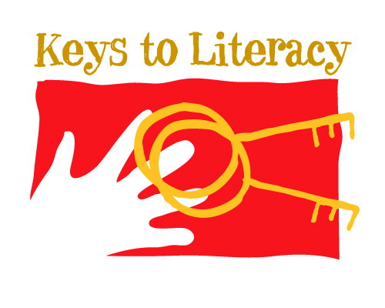

Name: Email:

I would like to learn more about the Letterland program for Pre-K to Grade 2 phonemic awareness and phonics.

____ Option 1
By participating in a 15-minute informational webinar. Register me for the following webinar (check one):

___ 3:30 pm (EST), Wednesday, September 27

___ 3:30 pm (EST), Tuesday, October 10

___ 3:30 pm (EST), Tuesday, October 31

___ 3:30 pm (EST), Wednesday, November 8

___ 3:30 pm (EST), Tuesday, November 28

___ 3:30 pm (EST), Tuesday, December 12

Questions? Please call Sue Nichols at 978-948-8511, Ext. 205

Please return this form via email to sue@keystoliteracy.com or fax at 978-948-8611.

