Understanding Dyslexia
For Elementary Teachers

Would you like to better understand dyslexia and how it affects students’ reading ability? This one-day seminar is just what you need!

There are many reasons why students have difficulty with reading and writing skills. For 10% to 15% of students the cause is dyslexia, a neurobiological learning disability that is characterized by difficulties with accurate or fluent word recognition and poor spelling.

This professional development provides the background knowledge about dyslexia that all teachers need in order to understand why students with dyslexia have difficulty with reading and how to support them in the classroom.

Approximately 6 hours of professional learning time, covering these topics:

- What is dyslexia? one type of specific learning disability, dyslexia defined and myths, signs of dyslexia

- The Reading Brain how the brain learns to read, dyslexia and the brain

- Dyslexia and the Five Components of Reading dyslexia and The Simple View of reading, effects of dyslexia on decoding/vocabulary/comprehension, emotional and motivational consequences, accommodations and modifications

- Screening for Dyslexia screening early, screening vs formal diagnosis, suggested screening battery

- Effective Instruction for Students with Dyslexia early intervention, overview of structured literacy instruction, teaching principles including gradual release, explicit and systematic instruction, differentiation, and scaffolding

- Structured Literacy Instruction – Sounds phonemic awareness, basic routines for blending/segmenting, advanced instruction for phoneme manipulation

- Structured Literacy Instruction – Sound-Symbol Correspondences the alphabetic principle, explicit phonics instruction, teaching letter-sound correspondences, phonics scope and sequence, blending and segmenting activities

- Structured Literacy Instruction – Syllable Types six syllable types, syllable division

- Structured Literacy Instruction – Morphemes prefixes/suffixes/roots, combining syllabication with structural analysis to read multisyllable words

Options for the professional development include live onsite, live virtual, asynchronous online course, or hybrid facilitated online course.

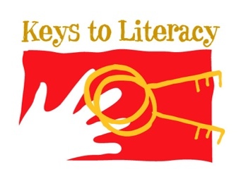
Contact Keys to Literacy to learn more:

info@keystoliteracy.com

Phone: 978-948-8511

