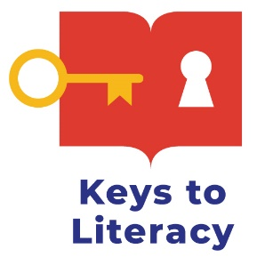
Order Form
Key Comprehension Routine

DIRECTIONS: Please complete and submit this form via email to amanda@keystoliteracy.com AT LEAST 3 WEEKS BEFORE THE FIRST TRAINING SESSION.

LEVEL I TRAINER INFORMATION
Name: Phone Number:
Email: Sponsoring Organization:

DATES OF TRAINING:

SHIPPING INFORMATION
Name:
School/District/Organization:
Address:
City: State: Zip:

BILLING INFORMATION
Name:
School/District/Organization:
Address:
City: State: Zip:
Phone Number: Email:

PAYMENT INFORMATION
☐ Check (made payable to Keys to Literacy, LLC)
☐ Purchase Order No.
Please attach signed PO or supply a date when the PO will be sent. PO must be submitted before books are shipped and participants are registered.

ORDER DETAILS
QUANTITY | ITEM # | DESCRIPTION | UNIT COST | ORDER TOTAL
 | KC-LC1 | Registration fee for Key Comprehension Routine Level I training (includes training book and online course) | $149 (per person)
 | Shipping | US Shipping & Handling: $10.00 for 1st & $2.00 for each additional item.
TOTAL AMOUNT DUE:

MAIL completed order form with check or Purchase Order to:
Keys to Literacy
319 Newburyport Turnpike, Suite 205
Rowley, MA 01969
OR
FAX or EMAIL completed order form with Purchase Order to (978) 948-8611 or amanda@keystoliteracy.com

Please allow three weeks for delivery.

